**Q3.** Store name of weekdays in an array (starting from “Sunday” at 0 index). Ask day position from user and print day name. Handle array index out of bound exception and give proper message if user enters day index outside range (0-6).

Input;

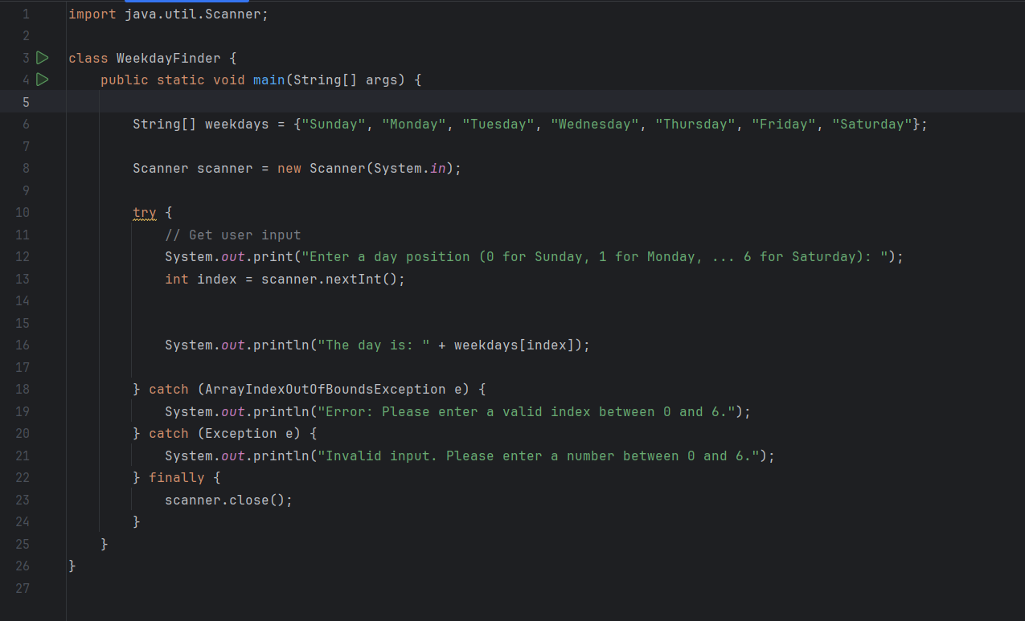

Output;

